Three State Air Quality Study

Non-NEPA Package Description and
Discussion Notes
DRAFT: 9/3/2014

The Three State Data Warehouse (3SDW) is a repository of air quality data related modeling, evaluation and visualization tools developed cooperatively by the Environmental Protection Agency (EPA) Region 8, Forest Service (FS), National Park Service (NPS), and Bureau of Land Management (BLM) and State agency offices in Colorado, Wyoming, and Utah State Offices.

The 3SDW offers pre-defined, cooperator approved, NEPA modeling data packages to support consistent AQ/AQRV Photochemical Grid Model (PGM) analysis for NEPA related projects, and the 3SDW also offers additional PGM resources for less constrained data requests which may support other regulatory, research or academic applications.

Information regarding 3SDW support of a NEPA process is contained in the 3SDW NEPA AQ/AQRV Process Outline, and additional information about each specific NEPA data package is available through the 3SDW in package specific Data Manifest files. General descriptions and considerations for “non-NEPA” data requests are described here.

- What support files will be available?

- Support files are not expected to be available as individual files, but rather as “packages” which are defined and assembled to support specific purposes. Currently, discussions have focused on the following resources:
- Meteorological data processing tools (e.g. WRF and GEOSCHEM configuration and support files)
- Emissions data processing tools (e.g. SMOKE configuration and support files)

- Modeling support files are currently available for the 2008 Base08b model runs Preliminary “packages” designed around 2008 data are currently being developed (see 3SDW_nonNEPA_Data_Package.xlsx).

- Several non-NEPA support projects are expected in the near-term which will use the 2011 modeling platform. These cases will be used as test cases to help defined a streamlined data packaging and dissemination process. These include:

- EPA ORD Program (Rebecca Matichuk as contact)
    - 2011 CMAQ platform
    - Results due by March 2015
    - Projected release date for 2011 CMAQ platform is November 2014
    - See notes from Rebecca’s 9/4 meeting
      - What input files are necessary?
      - Can any of the support files be prioritized for availability (would early release of some support files create a preliminary/final metadata field?)
- Denver O3 Modeling (Ralph Morris as data contact)
- NPS modeling (Mike Barna and Tammy Thompson as contacts)
- Southern NM O₃ Modeling (contact?)

- What will a user be required to provide prior to receiving data?

- Before a request can be made, a “project” will need to be set up which includes:
- A Clear Description and statement of need (metadata for tracking purposes)
- Implementation Schedule
- After a “project” is set up, user interface options will allow selection of non-NEPA “packages”.

See mock-ups, web links or web-page screenshots for project set-up and data request pages.

- What will a user be asked to provide back to the 3SDW for non-NEPA projects?

- Modifications to emissions?
- Model output results?
- Model input modifications/improvements?
- Would this require an acceptance/approval process before the 3SDW makes a new and improved data package available?

- Will model evaluation and emissions viewing tools be available for user modified files?

- The first phase of development will only support review of the base case and future no-action case NEPA scenarios
- Later versions of the 3SDW may be able to support user uploads of modeled data results, and evaluation of results using 3SDW visualization and summary tools.

General (Non-NEPA) Data Request
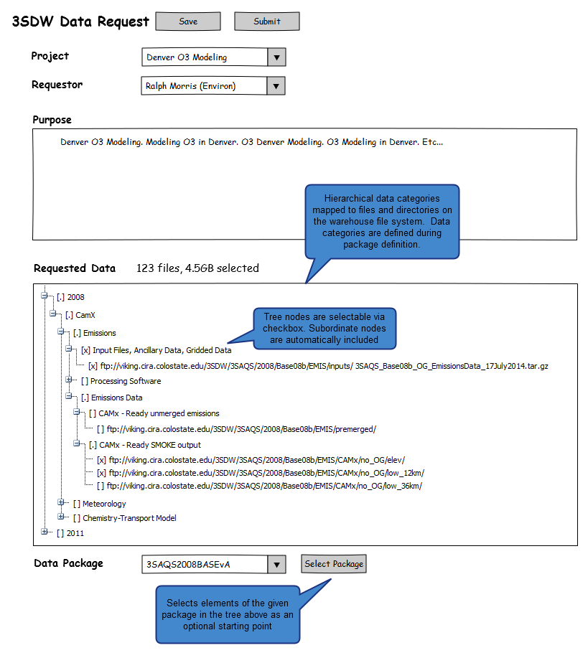

Data Package Viewer – Tree
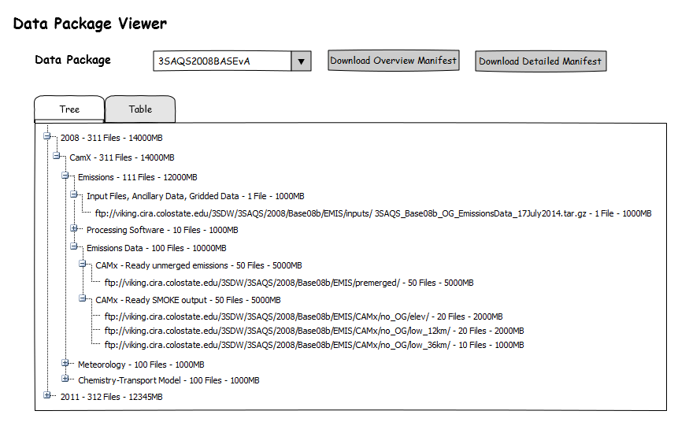

Data Package Viewer – Table
